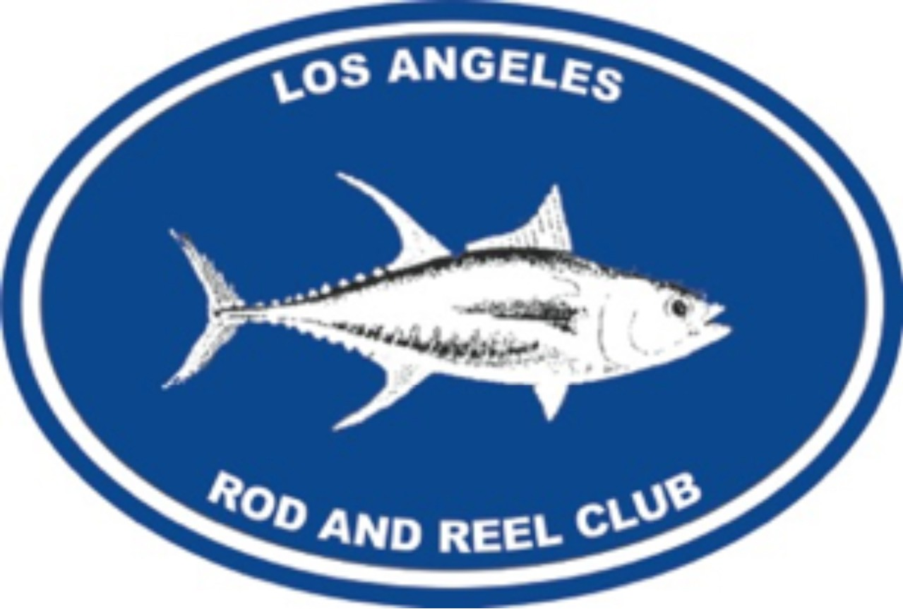
Los Angeles Rod and Reel Club Application for Membership

New Members Name:
Home Address: ____________________________________________
City: _____________________State: ___ Zip ___________
Sponsored by:
Cell Phone: Home Phone:_________ ___ Email: – Occupation: Name of Business - Work Phone - Type of Membership Applying For (Please Circle one) ACTIVE NON-RESIDENT (OUTSIDE OF CA.)
Areas of Interest (please check at least one)
Attending Meetings with Guest Speakers
Participating in Club Fishing Charters
Volunteering for L.A.R.R.C Foundation Charitable Activities
Raising funds for L.A.R.R.C. Foundation

Applicant’s Signature:_______________________ Date:

Membership Chairperson’s Signature -
President’s Signature Date of Approval by Board of Directors
Please print this form and mail or email to: info@larrc.org or
LARRC Membership
1751B Andreo Avenue
Torrance, California 90501

